Ideation Phase
Brainstorm & Idea Prioritization
 | 28 September 2026
Team ID | SWTID-2026-7972
Project Name | Comic Craft – AI Comic Story Creator using Gemini
Maximum Marks | 4 Marks

Brainstorm & Idea Prioritization Template:
Brainstorming provides a free and open environment that encourages everyone within a team to participate in the creative thinking process that leads to problem solving. Prioritizing volume over value, out-of-the-box ideas are welcome and built upon, and all participants are encouraged to collaborate, helping each other develop a rich amount of creative solutions.
Reference: https://www.mural.co/templates/brainstorm-and-idea-prioritization

Step-1: Team Gathering, Collaboration and Select the Problem Statement
Team roles (add names before submitting):
Role | Team member
Story & prompt design (Gemini text)
Image generation & character consistency
Frontend / comic layout
Testing, documentation & demo

Problem statement
How might we help people with no drawing skills turn a simple story idea into a complete, consistent, illustrated comic in minutes using Gemini?
Ground rules for the session: stay on topic, defer judgment, go for volume, encourage wild ideas, listen to others, and be visual where possible.

Step-2: Brainstorm, Idea Listing and Grouping
Ideas were listed first without judgment, then clustered into five themes:
Cluster | Ideas
Story generation | 1. Turn a one-line idea into a panel-by-panel script with dialogue.  2. Genre and tone picker (superhero, manga, kids, noir, comedy).  3. Character builder form (name, look, personality) reused in every panel.  4. "What happens next?" continuation and branching endings.
Visuals | 5. Generate one Gemini image per panel from the script.  6. Character reference sheet fed into every panel prompt for consistency.  7. Art-style presets (cartoon, manga, watercolor, pixel).
Editing & layout | 8. App-drawn speech bubbles and captions overlaid on the image.  9. Regenerate a single panel, edit text, or reorder panels.  10. Layout templates (4-panel strip, full page).
Output & reach | 11. Export as PDF/PNG.  12. Multi-language comics (English, Tamil, Hindi, etc.).  13. Education mode: turn a lesson or news story into a comic.
Wild ideas | 14. Voice narration / read-aloud mode.  15. Upload a selfie to become the hero.  16. Collaborative story mode where friends add panels.

Step-3: Idea Prioritization
Each idea was placed on a grid by importance (impact on users) and feasibility (cost, time, effort, complexity).
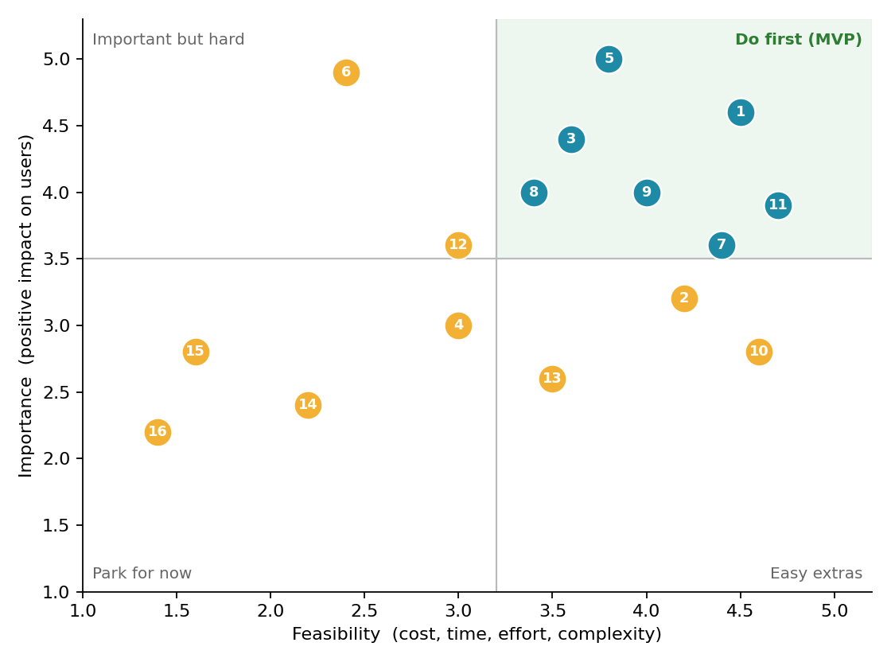
# | Idea | Importance (1-5) | Feasibility (1-5) | Decision
1 | Idea → script | 5 | 5 | Do first
3 | Character builder | 4 | 4 | Do first
5 | Image per panel | 5 | 4 | Do first
7 | Art-style presets | 4 | 4 | Do first
8 | Overlaid bubbles & captions | 4 | 3 | Do first
9 | Edit / regenerate panel | 4 | 4 | Do first
11 | Export PDF/PNG | 4 | 5 | Do first
6 | Character consistency (advanced) | 5 | 2 | Important but hard
2 | Genre & tone picker | 3 | 4 | Easy extra
10 | Layout templates | 3 | 5 | Easy extra
12 | Multi-language | 4 | 3 | Later
4 | Branching story | 3 | 3 | Later
13 | Education mode | 3 | 3 | Later
14 | Voice narration | 2 | 2 | Park
15 | Selfie-to-hero | 3 | 1 | Park
16 | Collaborative mode | 2 | 1 | Park

Selected for the MVP
- Story engine: idea → script with characters, genre and tone (ideas 1, 3).
- Visuals: Gemini-generated panel images with art-style presets (5, 7).
- Comic assembly: app-drawn bubbles and captions, panel editing, PDF/PNG export (8, 9, 11).
Key risk and how we handle it
- Keeping a character looking the same across panels is the hardest part. For the MVP, repeat a fixed written character description in every image prompt and reuse the same style preset; a full reference-sheet approach (idea 6) comes later.
- Image models draw text unreliably, so speech bubbles and captions are added by the app rather than generated inside the image.
- Selfie-to-hero and collaborative mode are parked because of privacy and complexity concerns.

